**Example datasets for Finiflux2.0 (Finite element method for quantifying groundwater fluxes to streams using Radon)**

By Ben Gilfedder and Sven Frei

*Limnological Research Station & Department of Hydrology, University of Bayreuth, Universitätsstrasse 30, 95447 Bayreuth, Germany*

Ok here is a description of two example datasets that we have packaged with FINIFLUX to show a simple scenario and a more complex case:

1. Simple case: Avon River Australia
2. More difficult/complex case: Selke River Germany

**Introduction**

In collecting and modelling radon activities in streams as part of our research we have come across different situations where, in some cases, simple modelling schemes fit well but in other cases more detail and complexity is required to adequately address the real-world process of groundwater discharge. The two examples given here are two extreme cases.

**Avon River Australia – Simple Case**

The radon data set used here is from the paper by Cartwright and Hofmann (2016). I did a fair amount of work in the group of Ian Cartwright during a Post-Doc between 2010-2013 and count Harald Hofmann as a good friend. The Avon River lies in the central part of the Gippsland Basin, Victoria Australia. It drains from Mt. Wellington (664 masl) in the north and runs 122 km into Lake Wellington in the South, the latter of which is connected to the southern ocean through the Gippsland Lakes system. About 30 % of the catchment lies in the mountainous headwaters, while the remaining 70 % is dominated by lowland plains with undulating hills. The flow regime has led to the development of a wide gravel river channel in the lowland sections of the river. However, during most of the year the river only occupies a small portion of the channel and tends to meanders through depressions in the gravel beds deposited during high flow events. This forms a series of riffle and pool sequences. As flow increases the river can become braded, following local scour depressions in the river bed. We have used 50 km of the middle and lower section of the Avon River as an ideal case because, due to the arid Australia climate, surface inflows (tributaries) are non-existent, and the river is a single channel solely fed by groundwater, at least at the time of sampling. This comes as close as possible to the ‘two box’ concept of groundwater - surface water interactions. Due to the course bed materials there is also a degree of hyporheic exchange.

The data for the Avon can be found in the FINIFLUX.XLSX file in the Avon folder downloaded with the other data within the ‘Examples’ folder. You will see the bare minimum of input data, with nothing added in the tributary fields, or in the degassing column. Reach length range between 700 m and 8 km and radon activities between 170 Bq m-3 and 2000 Bq m-3 with a pronounced ‘hot-spot’ in the middle reaches. Groundwater radon activities were held constant at 20,000 Bq m-3. The FINIFLUX model was initialised with 4 slaves and a master and hyporheic exchange was turned on with a power law RTD. The measured and modelled values can be seen below as well as the cumulative groundwater flux. Due to the ideal conditions for FINIFLUX modelling on the Avon (the empirical degassing model are made for rivers such as this) the fit is exceptional. The water balance is however slightly over estimated, which is due to parafluvial flow through cobble and gravel banks and meanders appearing as groundwater due to residence times above 21 days. This is discussed in detail in the above listed paper.

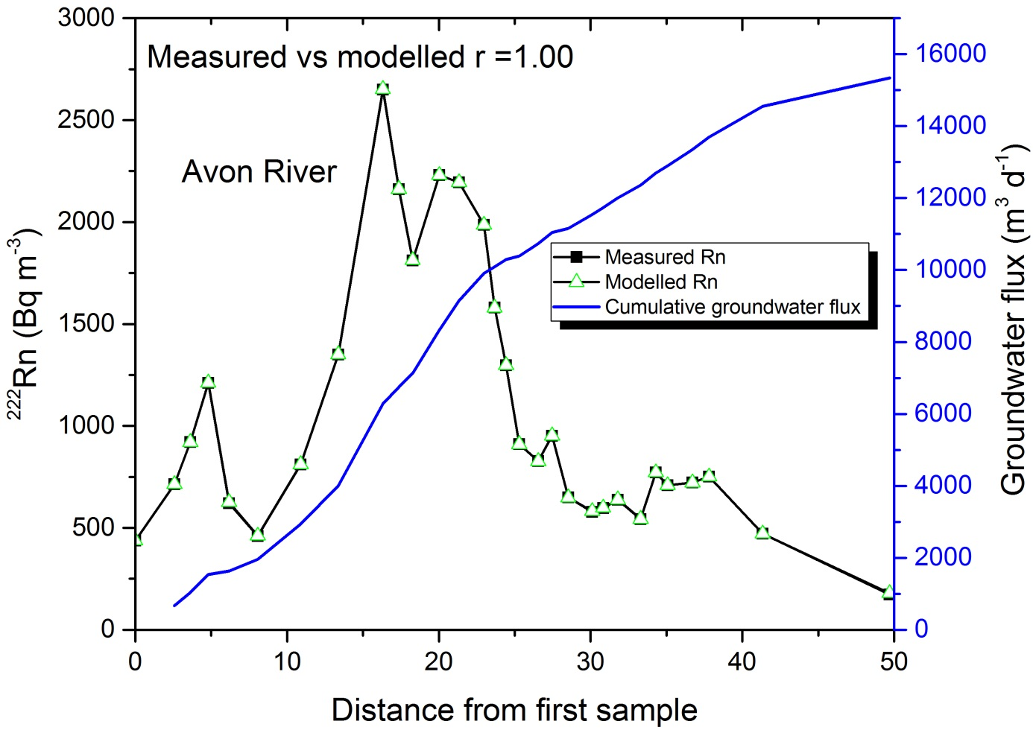

**Selke River, Germany**

The Selke River is a much more complex system. It drains the Harz Mountains in middle-Germany and flow from north to the south before joining the Bode river. It starts off in mountainous headwaters, moves through an upper catchment plateau, before draining onto gravel bed lowland areas with intensive agriculture. The Selke has many tributaries, the largest of which we have measured. It is also known from previous studies from the group of Prof. Jan Fleckenstein that the lower reaches of the river are both loosing and gaining, so that water flows out of the channel in some reaches and re-joins the channel a few km further downstream. This can be seen by differential gauging. There is also a water fall in the middle reaches complicating the degassing further. So what have we done to model radon activities and groundwater discharge in this complex hydrological system? The input file can be found in the folder ‘Selk’ within the ‘Examples’ folder. The basic parameters such as CPUs and residence time distribution has been kept the same as for the Avon. First let’s have a look at the ‘nodes’ or measurement points:

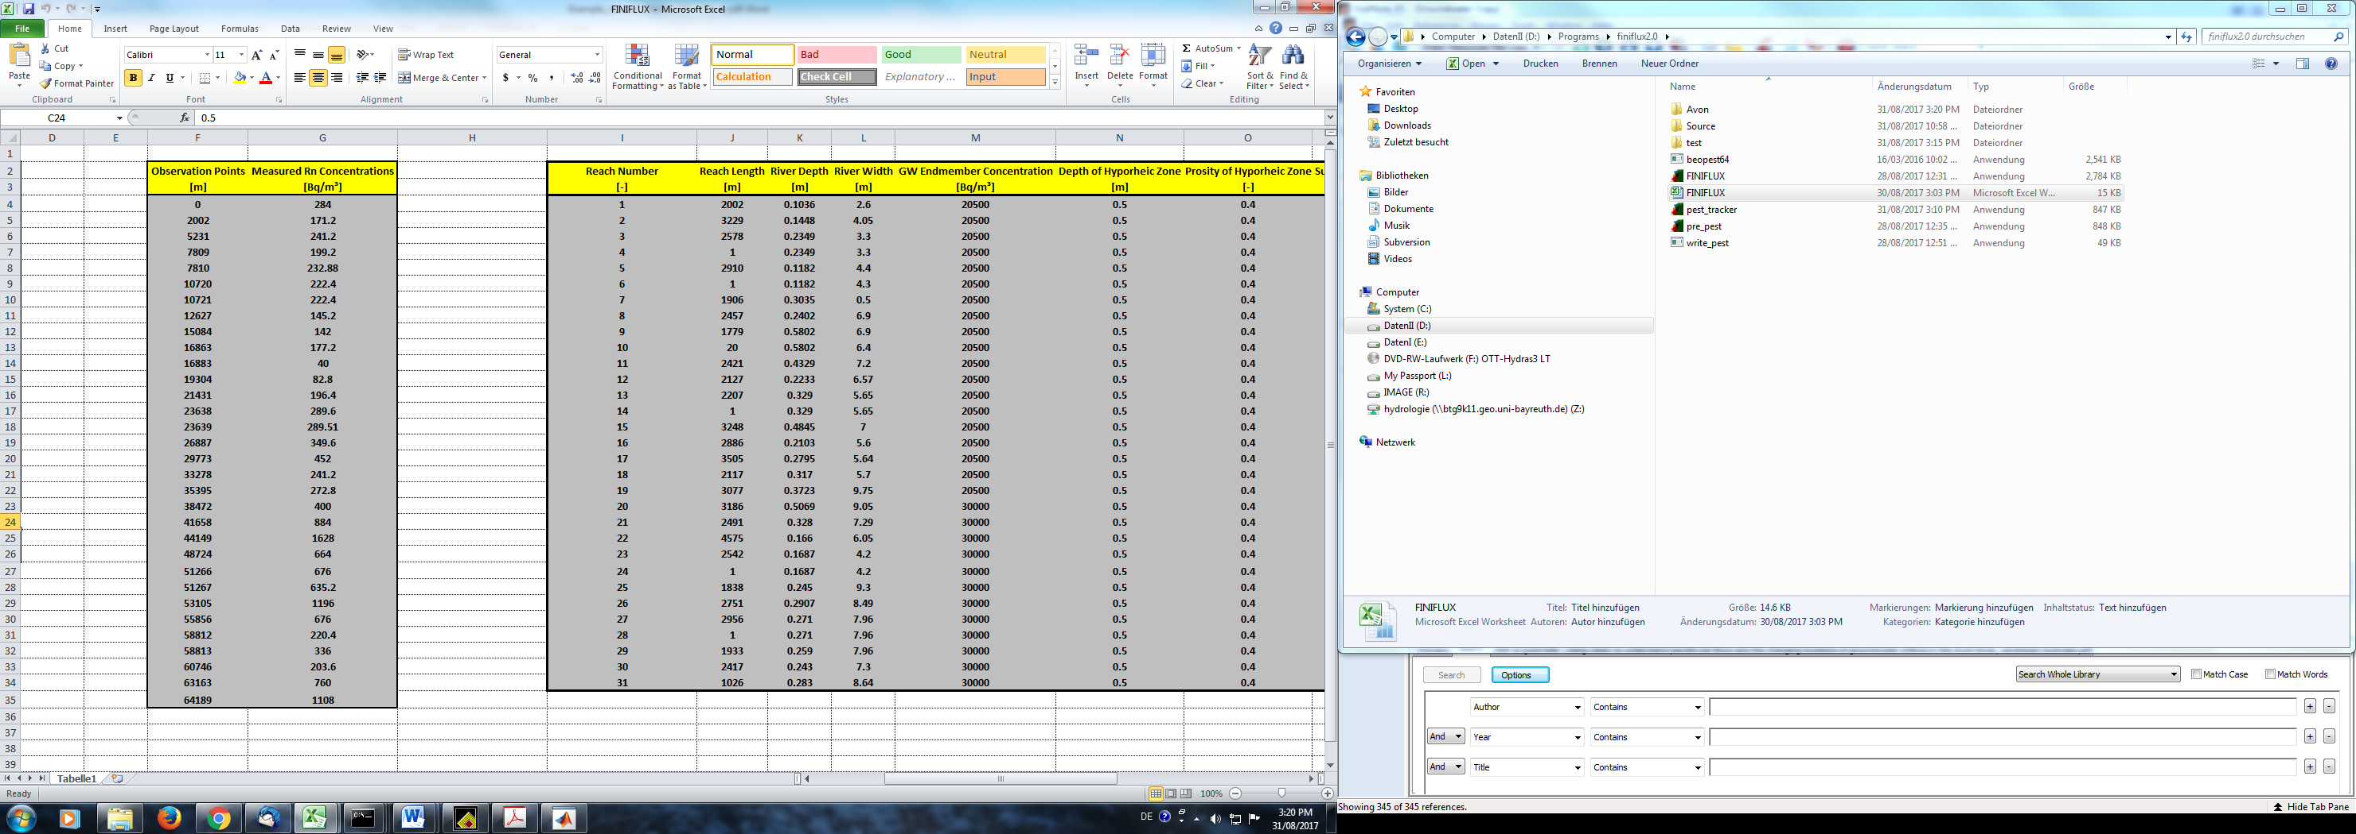

20 m reach with waterfall (extreme degassing)

Tributary with width of 1m

Tributary with width of 1m

Tributary with width of 1m

Tributary with width of 1m

Tributary with width of 1m

One can see that in the observation points there are five sections where the length increases by only 1m. The first number corresponds to the sampling point above the confluence of the rivers, and has an associated radon activity. The second observation point is below the confluence and so contains a mixed chemistry between the upstream sample and the tributary. This mix signal also has a radon activity. This can be measured or calculated using a standard mixing model.

Next we have a look at the ‘elements’ or reaches.

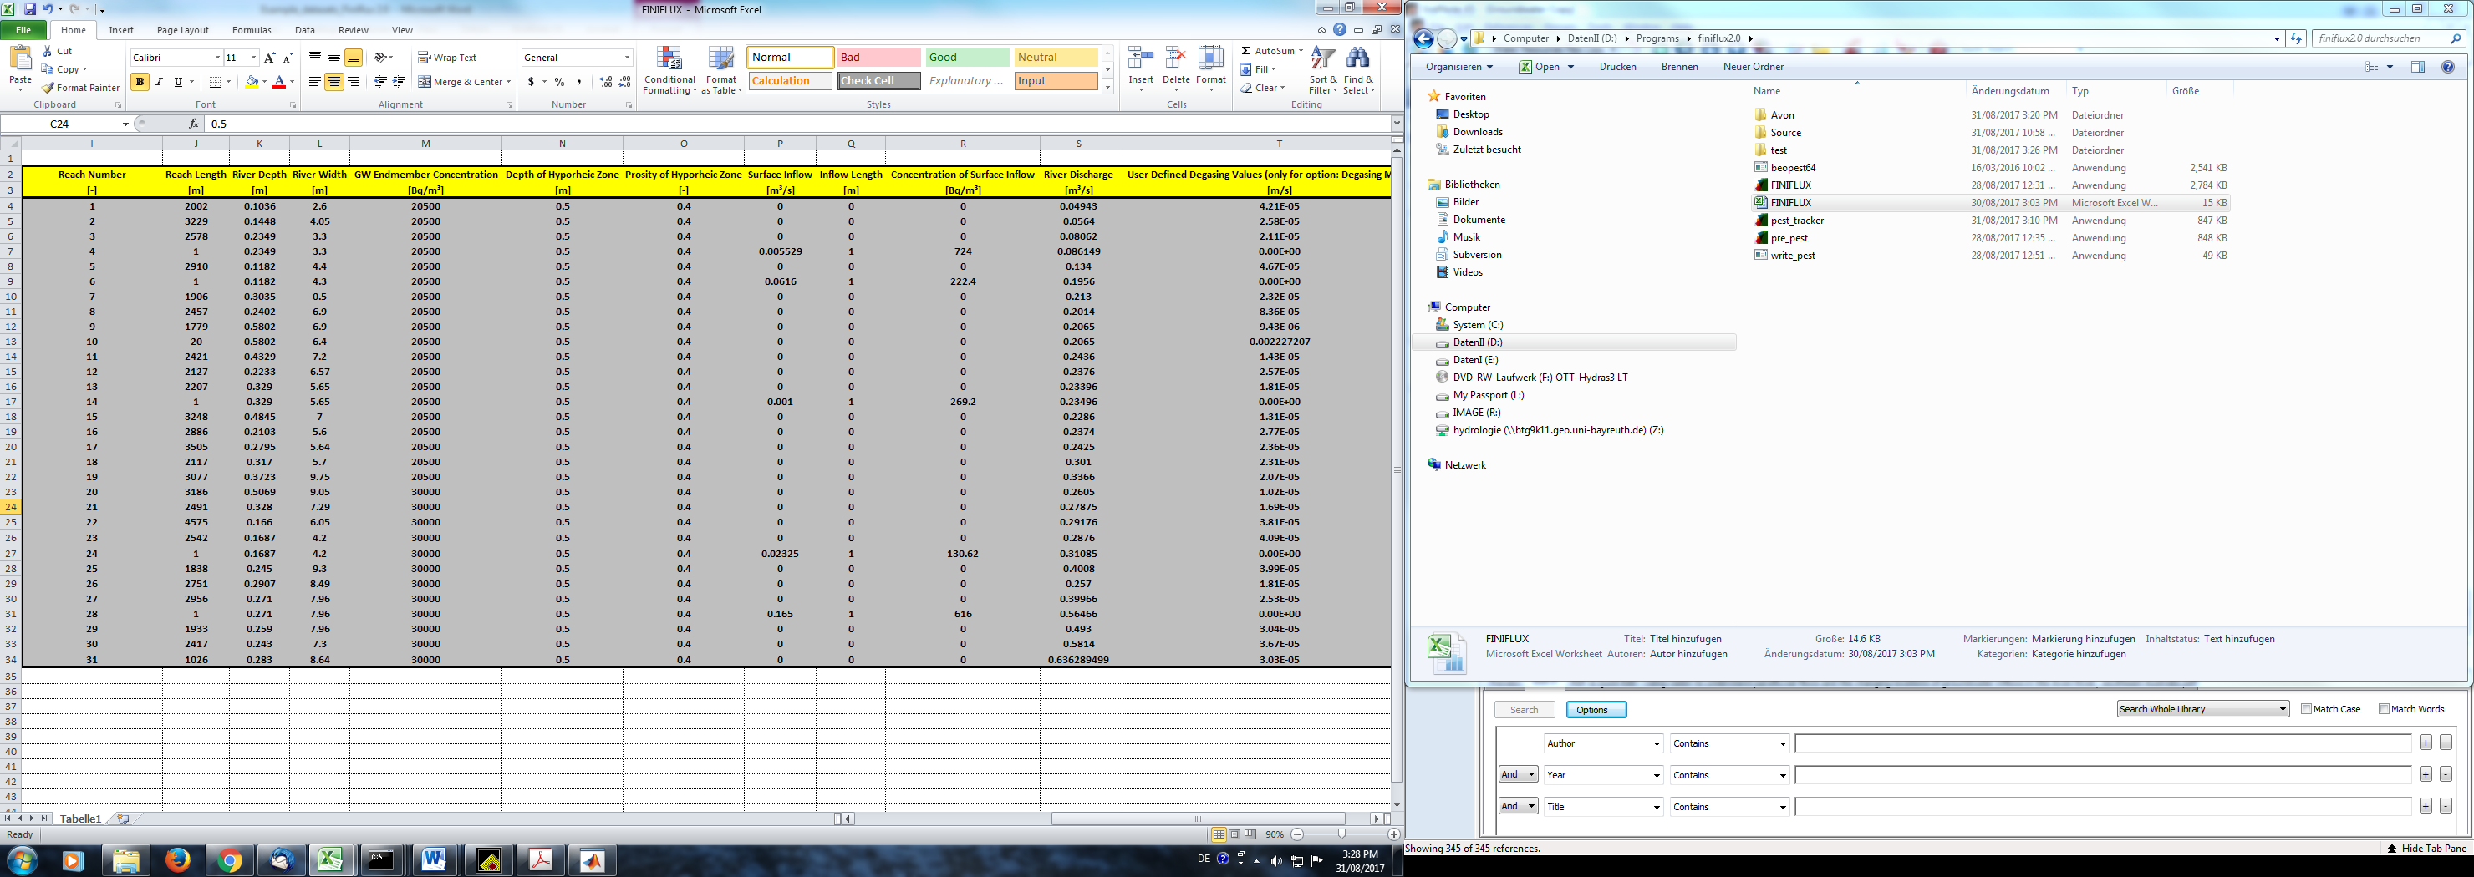

Firstly we see that there is one less reach than sampling point as expected. In the river length section we can see where the tributaries come in, as they only have a length of 1m compared to other reaches which are over 1000 m in length. It is also clear where the reach with the water fall is since it only has a length of 20 m. Next we can have a look at the inflow data. Firstly the inflow length is given as the width of the inflow, as expected in our case 1 m. The concentration of surface inflow is as expected, the tributary radon activity.

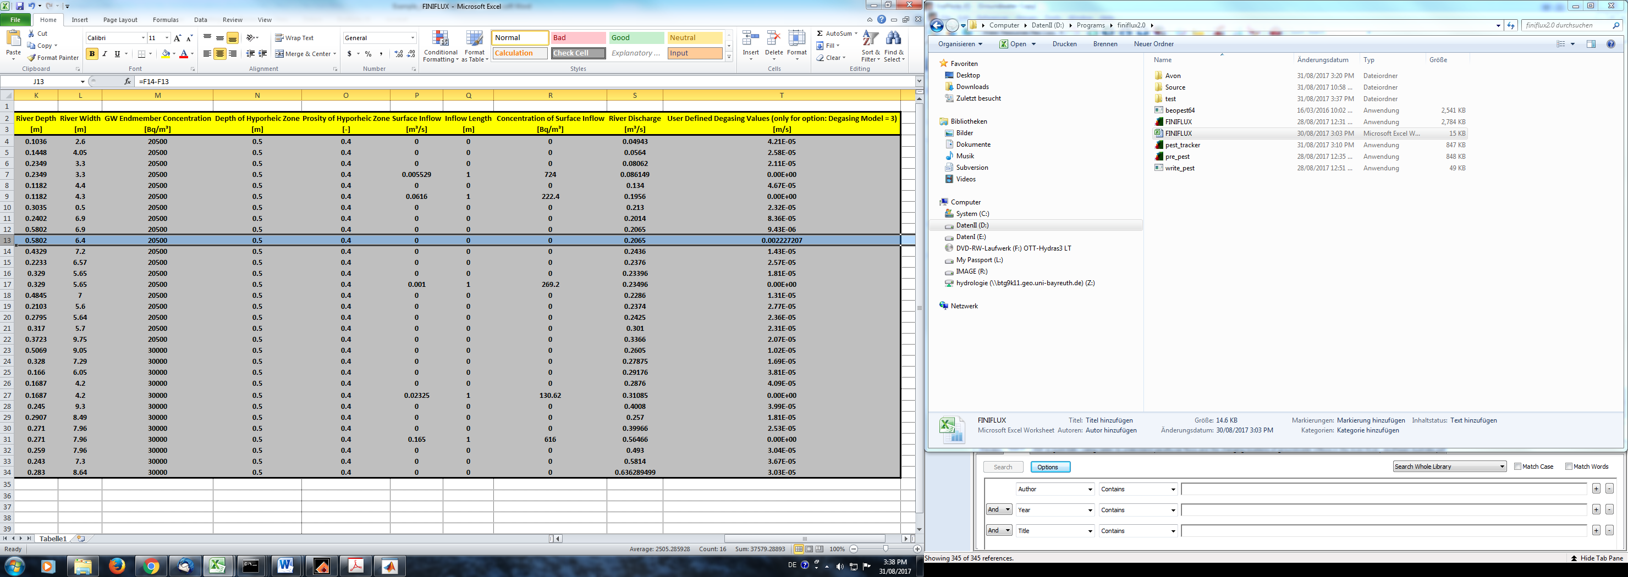

In the case of the Selke we had a degassing problem with the waterfall. Such turbulent degassing cannot be accounted for by the empirical degassing models. So what we did is assume that the change in radon over the 20 length following the water fall was all due to degassing and thus calculated the value of k. For the rest of the river we calculated the degassing using the empirical model 1 off-line and then copied the values into the spreadsheet as if we had measured them. It is always best to measure degassing, but this is hard, especially over long rivers. We have also found that the empirical models work pretty well when comparing conservative Cl- and radon (Atkinson et al., 2013). The model was then run, with very satisfactory results, at least in terms of the radon fits.

Here is the plot from Pest_checker, which monitors BeoPEST progress during the optimisation:



Measured vs. Modelled

Measured

modelled

Here is the final plot of modelled and measured radon activities as well as the calculated cumulative groundwater fluxes.

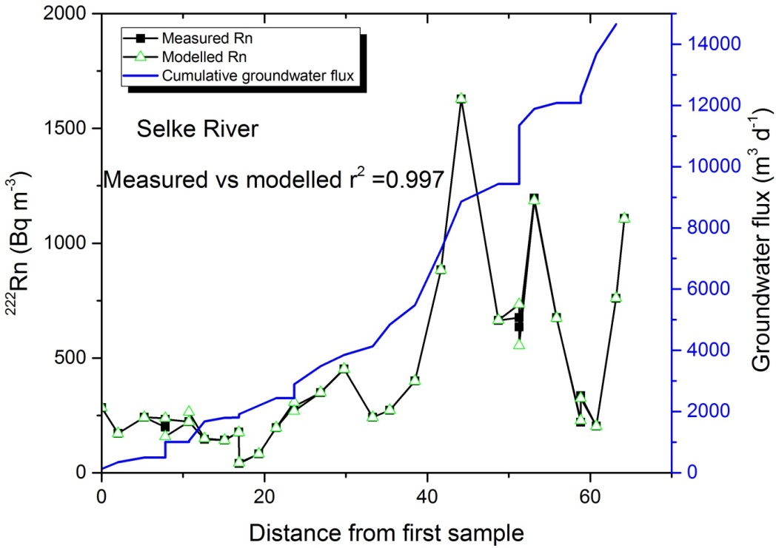

We hope these examples help with your implementation of FINIFLUX across systems with varying complexity.

**Atkinson, A.P., Cartwright, I., Gilfedder, B.S., Hofmann, H., Unland, N.P., Cendón, D.I., Chisari, R., 2013. A multi-tracer approach to quantifying groundwater inflows to an upland river; assessing the influence of variable groundwater chemistry. Hydrological Processes, doi: 10.1002/hyp.10122.**

**Cartwright, I., Hofmann, H., 2016. Using radon to understand parafluvial flows and the changing locations of groundwater inflows in the Avon River, southeast Australia. Hydrology and Earth System Science 20, 3581–3600; doi:3510.5194/hess-3520-3581-2016.**